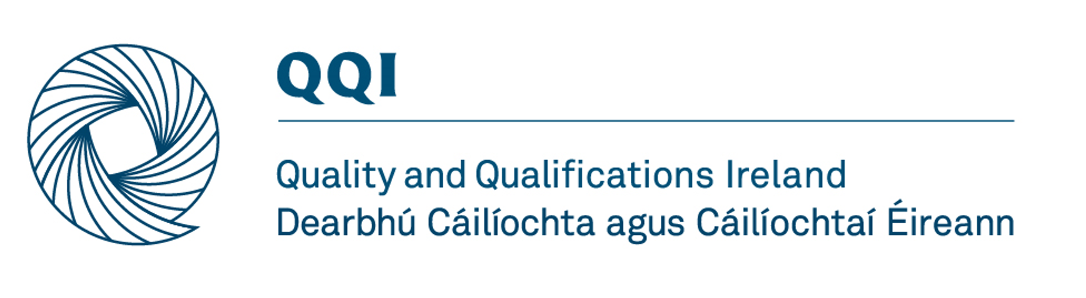
Kildare and Wicklow Education and Training Board –
Inaugural Review of Quality Assurance in
Education and Training Boards 2022

The Review Team

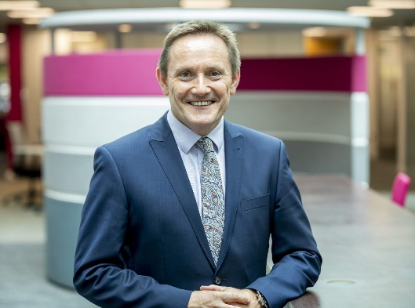 | Chair  David Jones stepped down as Chief Executive/Principal of Coleg Cambria at the end of 2019 after steering the institution to great acclaim. A champion of work-based learning, apprenticeships, fundraising and accessible education for people of all ages, he has made a vast contribution to shaping the careers of tens of thousands of youngsters and mature learners over more than three decades. Initially a chartered electronics engineer, as the CEO/Principal of Deeside College from 2004, he led its mergers from 2009 to 2013 with the Welsh College of Horticulture, Llysfasi College and Wrexham’s Yale College, to create Coleg Cambria.  In addition to a wide range of previous non-executive appointments, David is currently the Chair of Qualifications Wales, a board member of the Defence Electronics Component Agency (DECA) and the Wales Appeals Board of NSPCC Wales, and chaired the inaugural review of Laois and Offaly ETB. He is also a commissioner for the UK-wide Independent Commission on the College of the Future, which published its initial reports in 2020.
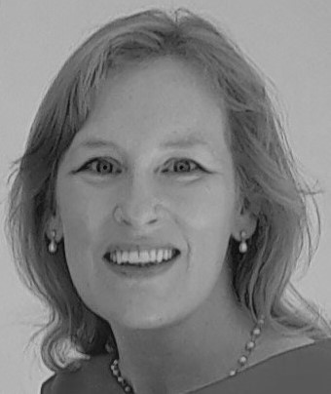 | Coordinating Reviewer  Dr Deirdre Stritch is an independent education and QA consultant. Until end of August 2021, she held a number of roles with Quality and Qualifications Ireland (QQI).  Most recently, she was Quality Assurance Approval and Monitoring Manager and Programme Manager for Academic Integrity Initiatives. In that role, she led QQI’s ‘reengagement’ process, which saw the QA evaluation of all QQI-regulated private and voluntary sector HE and FE providers.  Deirdre has significant regulatory experience with private and public providers, and has represented Ireland in a  number of international fora, including the Council of Europe; the European Commission; the European Network for Quality Assurance and the European Network for Academic Integrity. She has participated in national steering groups dealing with the internationalisation of Irish education and developing new regulatory structures for international learners. She was also responsible for implementing new legislation pertaining to the criminalisation of contract cheating which was introduced at the end of 2019.  Previously, she managed projects related to the development and implementation of the National Framework of Qualifications and the recognition of qualifications with the National Qualifications Authority of Ireland and on national higher education policy development with the Higher Education Authority and the Royal Irish Academy.
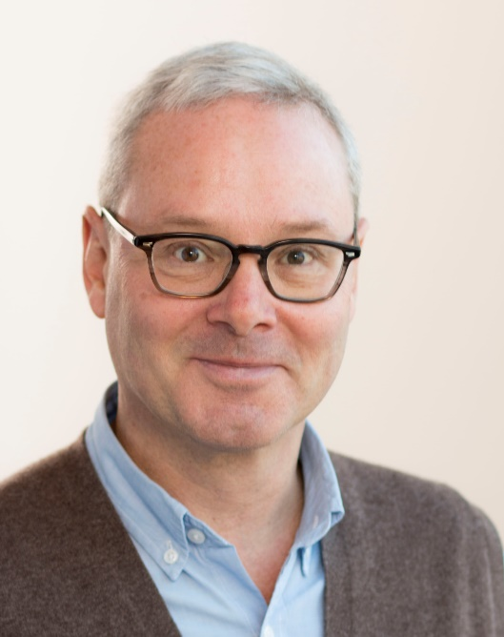 | Hans Almgren has been involved in vocational education and training since 2000. He is a former principal of an upper secondary VET-provider in Sweden and director for Education of the Swedish National Agency for Education.  He is currently working as a senior advisor of the Swedish National Agency for Higher Vocational Education.  He has been coordinator of the Swedish national reference point for EQAVET and ECVET, and is member of a team evaluating the Norwegian NQF.
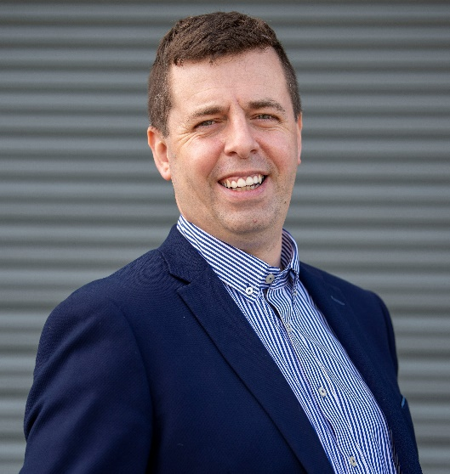 | Willie Mc Mahon is presently co-owner and director of CalX Instrumentation Services ltd. Career background is in industrial manufacturing environments from the aspect of instrumentation and calibration to enable same.  He grew up on a farm in north Meath, served an instrumentation apprenticeship in a very large local mine and has worked in various industries across Ireland in the intervening years providing calibration support to clients.  Having been self-employed since 2015, in 2019 he merged that business with another local business and today they employ 42 people. He is not only passionate about apprenticeships, but all 3rd level education in general and empowering the next generation.  His workplace currently employs 10 apprentices across 4 disciplines and have been short listed for Apprenticeship employer of the year 2021.  Married to Claire, Willie has three children and shares their house with a lot of pets.
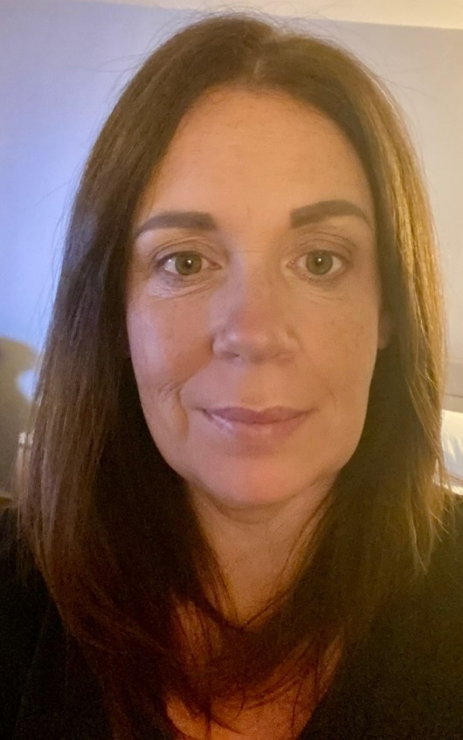 | After leaving secondary school, Maura Field completed a secretarial course and went to work as a secretary in a purchasing department for an electronics company. She became very interested in the work and after a short time, was hired as a junior buyer. She worked as a buyer and customer service representative in the private sector for almost 20 years. After having her second child, she made the decision to be a stay at home parent. Once her children were settled in primary school, she wanted to look at a career which would work for her family situation.  In 2019, Maura achieved a level 5 qualification in Early Childhood Care and Education at the local secondary school who were providing FET courses. In 2020/2021 during Covid-19lockdown, she completed the level 6 Advanced Early childhood care and education (special needs) online with the Cork College of Commerce.  Since receiving her qualifications, she is working as a substitute Special Needs Assistant.
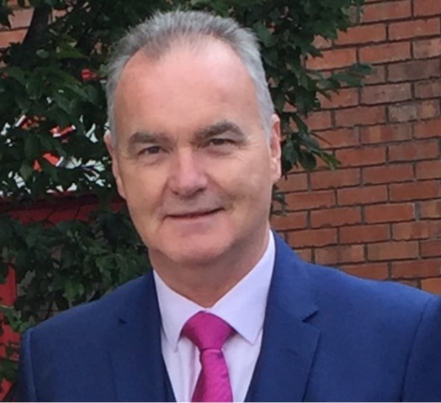 | David Treacy was an Education Officer with City of Dublin Education and Training Board for over 12 years. He dealt with the management and development of the CDETB Further Education and Training Services, providing adult education and training programmes and services across the city in community centres, colleges, training centres, prisons and in the workplace.  Prior to his role with CDETB, David was a director on the City of Dublin Youth Service Board - the youth work development agency of the City of Dublin Vocational Education Committee. He has also worked as a Youth Work Assessor in the Department of Education and Science.  David chairs panels for QA approval processes for QQI and has most recently chaired reengagement evaluations for the National Adult Literacy Agency and International Centre for Security Excellence.

